**WEEK 2 LAB 1**

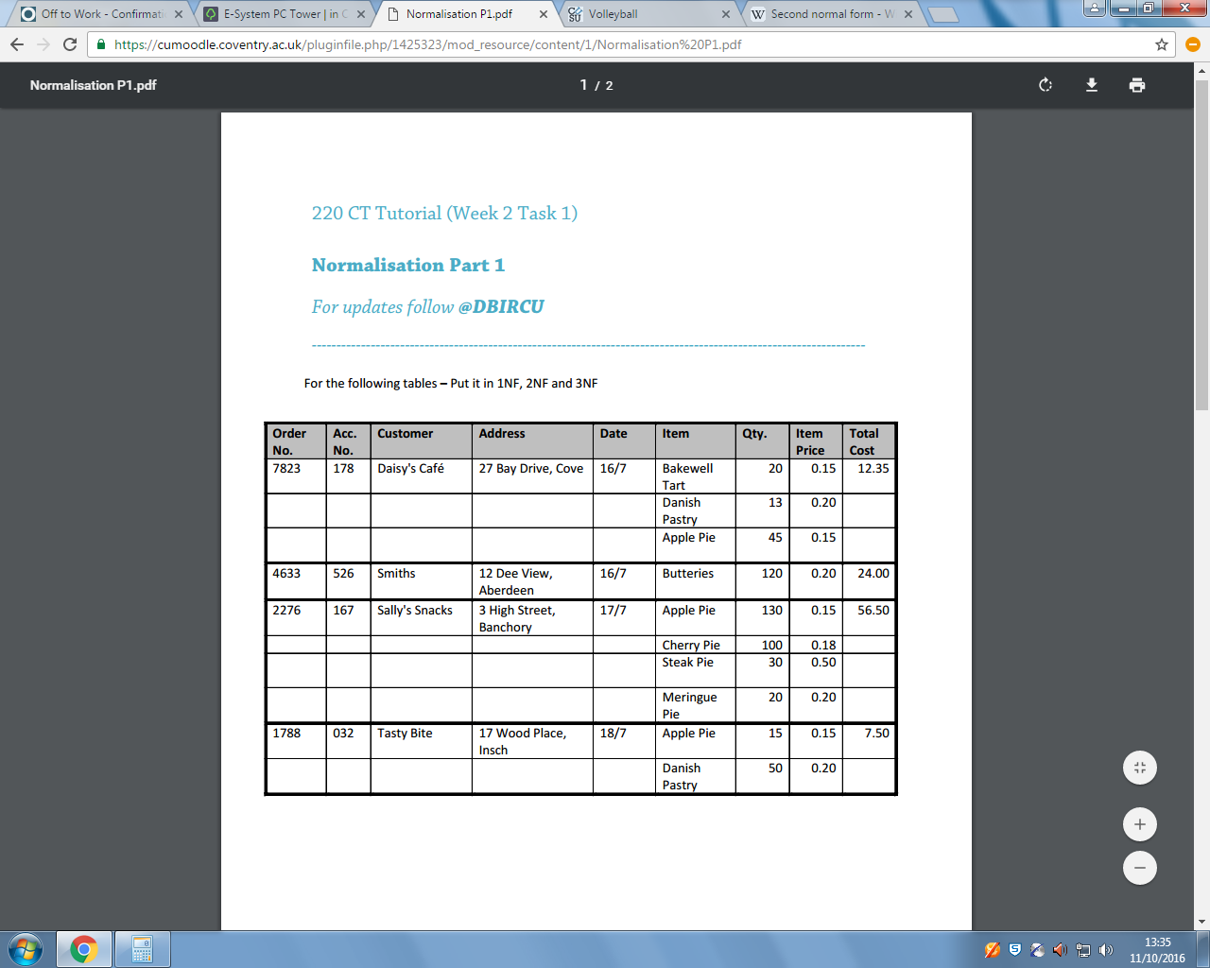

|  |  |  |  |  |  |
| --- | --- | --- | --- | --- | --- |
| **Order No** | **AccNo** | **Customer** | **Address** | **Total Cost** | **Date** |
| **7823** | **178** | **Daisy’s Cafe** | **27 Bay Drive, Cove** | **12.35** | **16/7** |
| **4633** | **526** | **Smiths** | **12 Dee View, Aberdeen** | **24.00** | **16/7** |
| **2276** | **167** | **Sally’s Snacks** | **3 High Street, Banchory** | **56.50** | **17/7** |
| **1788** | **032** | **Tasty Bite** | **17 Wood Place, Insch** | **7.50** | **18/7** |

**1NF  
Customers**

**ITEMS**

|  |  |  |  |
| --- | --- | --- | --- |
| **Order No** | **Item** | **Qty** | **Price** |
| **7823** | **Bakewell Tart** | **20** | **0.15** |
| **7823** | **Danish Pastry** | **13** | **0.20** |
| **7823** | **Apple Pie** | **45** | **0.15** |
| **4633** | **Butteries** | **120** | **0.20** |
| **2276** | **Apple Pie** | **130** | **0.15** |
| **2276** | **Cherry Pie** | **100** | **0.18** |
| **2276** | **Steak Pie** | **30** | **0.50** |
| **2276** | **Meringue Pie** | **20** | **0.20** |
| **1788** | **Apple Pie** | **15** | **0.15** |
| **1788** | **Danish Pastry** | **50** | **0.20** |

**2NF**

Order No, Acc No, Customer, Address, Total Cost, Date

Order No, Date , Total Cost